***FITNESS GURU***

*A*

*Project Report*

*Submitted in partial fulfilment of the*

*Requirements for the award of the Degree of*

**BACHELOR OF ENGINEERING**

IN

**INFORMATION TECHNOLOGY**

By

**BANDARU BHAVANA (1602-19-737-070)**

**KHIZRA NAUSHAD (1602-19-737-076)**

**STHAVARA SAATHVIKA (1602-19-737-091)**

*Under guidance of*

**KEZIA RANI**

**Professor**



**Department of Information Technology**

**Vasavi College of Engineering (Autonomous)**

**(Affiliated to Osmania University) Ibrahimbagh,**

**Hyderabad-31 2021-2022 Vasavi College of Engineering (Autonomous)**

**(Affiliated to Osmania University) Ibrahimbagh, Hyderabad-31**

**Department of Information Technology**



**DECLARATION BY THE CANDIDATES**

We, **B**. **BHAVANA, K. NAUSHAD AND S. SAATHVIKA** bearing hall ticket numbers, **1602-19-737-070, 1602-19-737-076, 1602-19-737-091** hereby declare that the project report entitled “**FITNESS GURU**” under the guidance of **KEZIA RANI**, Professor, Department of Information Technology, Vasavi College of Engineering, Hyderabad, is submitted in partial fulfilment of the requirement of MINI PROJECT of V semester of **Bachelor of Engineering in Information Technology**.

This is a record of bonafide work carried out by us and the results embodied in this project report have not been submitted to any other university or institute for the award of any other degree or diploma.

**BANDARU BHAVANA (1602-19-737-070)**

**KHIZRA NAUSHAD (1602-19-737-076)**

**STHAVARA SAATHVIKA (1602-19-737-091)**

**Vasavi College of Engineering (Autonomous)**

**(Affiliated to Osmania University) Ibrahimbagh, Hyderabad-31**

**Department of Information Technology**



**BONAFIDE CERTIFICATE**

This is to certify that the project entitled "**FITNESS GURU**” being submitted by **B. BHAVANA, K. NAUSHAD, S. SAATHVIKA** bearing **1602-19-737-070, 1602-19-737-076, 1602-19-737-091** in partial fulfilment of the requirements for the completion of MINI PROJECT of Bachelor of Engineering in Information Technology is a record of bonafide work carried out by them under my guidance.

**KEZIA RANI Dr. K. Ram Mohan Rao**

**Professor HOD, IT**

**Internal Guide**

**ACKNOWLEDGEMENT**

The satisfaction that accompanies that the successful completion of the project would not have been possible without the kind support and help of many individuals. We would like to extend my sincere thanks to all of them. We would like to take the opportunity to express our humble gratitude to **KEZIA RANI** (Professor) and **HASEEBA YASEEN(**Professor) under whom we executed this project. We would also use this opportunity to thank our Head Of Department Dr. K.Ram Mohan Rao. We would also like to thank all faculty members and staff of the Department of Information Technology for their generous help in various ways for the completion of this project.

**ABSTRACT**

Health care system is a major part of our lives now. Being fit helps you stay physically and mentally active. Regular exercise and physical activity promote strong muscles and bones. It improves respiratory, cardiovascular health, and overall health. This website will help people by helping them to keep themselves healthy by exercising and maintaining diets. This website contains of various types of exercises, diet plan, contact of trainers, dietician. User can register themselves and can choose type of exercise they want and can even set remainder. All the health benefits will be separately shown for each exercise.

**INDEX**

**CHAPTER1** **Title andDescription 1**

1.1 Motivation 1

**Software Requirements Specifications 2**

2.1 Introduction 2

2.1.1 Purpose 2

2.1.2 Scope 2

2.1.3 Definitions, Acronyms and Abbreviations 2

2.1.4 Overview 2

2.2 General Description 3

2.2.1 Product Perspective 3

2.2.2 Product Functions 3

2.2.3 User Characteristics 3

2.3 Modules Description 4

2.4 System Requirements 5

2.4.1 Hardware Requirements 5

2.4.2SoftwareRequirements 5

2.4.3DesignConstraints 6

**CHAPTER 3**

**Related Work 7**

**CHAPTER 4**

**System Design 8**

4.1 Architecture and Technology used 8

4.2 UML Diagrams 9

4.2.1 Use-case Diagram 9

4.2.2 Sequence Diagram 10

**CHAPTER 5**

**Implementation 11**

5.1 System Architecture (design) 11

5.2 Implementation and code 12

**CHAPTER 6**

**Results 13**

6.1 Database Design 22

**CHAPTER 7**

**Testing 23**

**CHAPTER 8**

**Conclusion and Future Scope 24**

**CHAPTER 9**

**References 25**

# CHAPTER 1

# TITLE DESCRIPTION

Fitness guru is a web application we have developed to provide a platform to the people who are unhealthy/unfit and for the people who want to adapt a healthy lifestyle for which this application helps them in numerous ways. This application will be very practical and handy for every individual whose goal is to lose weight or become fit.

### **1.1Motivation**

Now a days most of the people are suffering from obesity due to unhealthy lifestyle and they are not giving proper time for their own body to workout. Due to the covid – 19, all the gyms were closed and nobody has access to the gym. This application will help them to follow a workout routine and also maintain a diet. With the help of this application, they can track their weight loss and progress of their respective goals. As it is an online application they can easily access and follow their routines in online.

# CHAPTER 2

# SOFTWARE REQUIREMENTS SPECIFICATIONS

## **2.1 Introduction**

#### **2.1.1 Purpose**

In search of proper platform that aids people to follow their fitness journey and help them to adapt a healthy lifestyle. To improve their mental and physical health by following healthy diets, workout routines, tracking their progress using the application.

#### **2.1.2 Scope**

With the help of this website user will be able to select their type of workout, healthy diets according to their need or interests. User will be able to follow a workout regime and follow a healthy diet to achieve their goals.

#### **2.1.3 Definitions, Acronyms and Abbreviations**

**Abbreviations:**

**VS: Visual Learning**

#### **2.1.4 Overview**

The specifications include product perspective and the functionalities that the system will provide. The user characteristics, any general constraints or assumptions and dependencies are discussed below.

Requirements are categorized as performance, non-functional requirements and design constraints. Non-functional requirements are scalability, maintainability and dependence.

## **2.2 General Description**

#### **2.2.1 Product perspective**

Fitness guru provides features for client users such as accessing different workouts, diets according to their interests and health, tracking their progress through VS. The current design goal is to build a system to achieve the functionality outlined in the specification

#### **2.2.2 Product Functions**

Fitness guru gives a list of all kinds of diets like: keto diet, low carb diet, intermittent fasting and many more. It will also give a list of different workouts like yoga, body weight exercises, Zumba, HIIT (High intensity interval timing) exercises etc.

#### **2.2.3 User Characteristics**

1. **Student/user:** 
   * + The user can register in our website free of cost.
     + He/she can and access the features after logging in.
     + They can access their desired course, preview various MNC’s and build their resume exclusively.

1. **Administrator:** 
   * + Admin is responsible for maintaining and updating website
     + Admin has access to database.

## **2.3 Modules Description**

* **Login/Signup:**

In this module, the user can log into their respective accounts and use the website as desired. If the client is not an already existing user, he/she can create a new account by signing up.

* **Visual Learning:**

In this module, the users can access to different types of diets and workouts. When the required diet/workout is selected, the website instantly redirects the user to the required diet/workout.

* **Workout or Diet information:**

In this module, the user can access to various types of diets and workout plan’s information and their advantages.

## **2.4 System Requirements**

#### **2.4.1 Hardware Requirements**

* 1GB RAM
* 1GB CORE

#### **2.4.2 Software Requirements**

* **INTERPRETER:**

Visual Studio Code- It features a lightning-fast source code editor, perfect for day-to-day use. With support for hundreds of languages, VS Code helps you be instantly productive with syntax highlighting, bracket-matching, auto indentation, box-selection, snippets, and more.

• **BOOTSTRAP- WEB DESIGNING:**

Bootstrap is a free and open-source front-end framework for designing websites and web applications. It contains HTML- and CSS-based design templates for typography, forms, buttons, navigation and other interface components, as well as optional JavaScript extensions.

## **2.5 Design Constraints**

* Software Constraints: Users can run this application in windows.
* Hardware Constraints: The system will run on a core processor with minimum 400MB ram.
* Acceptance Criteria: Before accepting, the developer must check whether the application is running properly or not and should also check whether the data is stored correctly.

**RELATED WORK**

* <https://www.healthifyme.com/in/>
* <https://www.fittr.com/>

**CHAPTER 4 SYSTEM DESIGN**

**4.1 Architecture and Technology Use**

**Front-End:**

1. HTML
2. CSS
3. JAVA SCRIPT 4) BOOTSTRAP

**Back-End:**

1. SQLlite3
2. FLASK

**4.2 UML Diagrams**

* + 1. **Use-case Diagram**

Use case diagrams are the diagrammatic representations depicting users' interactions with the system. This diagram shows different types of users and various ways in which these users interact with the system.

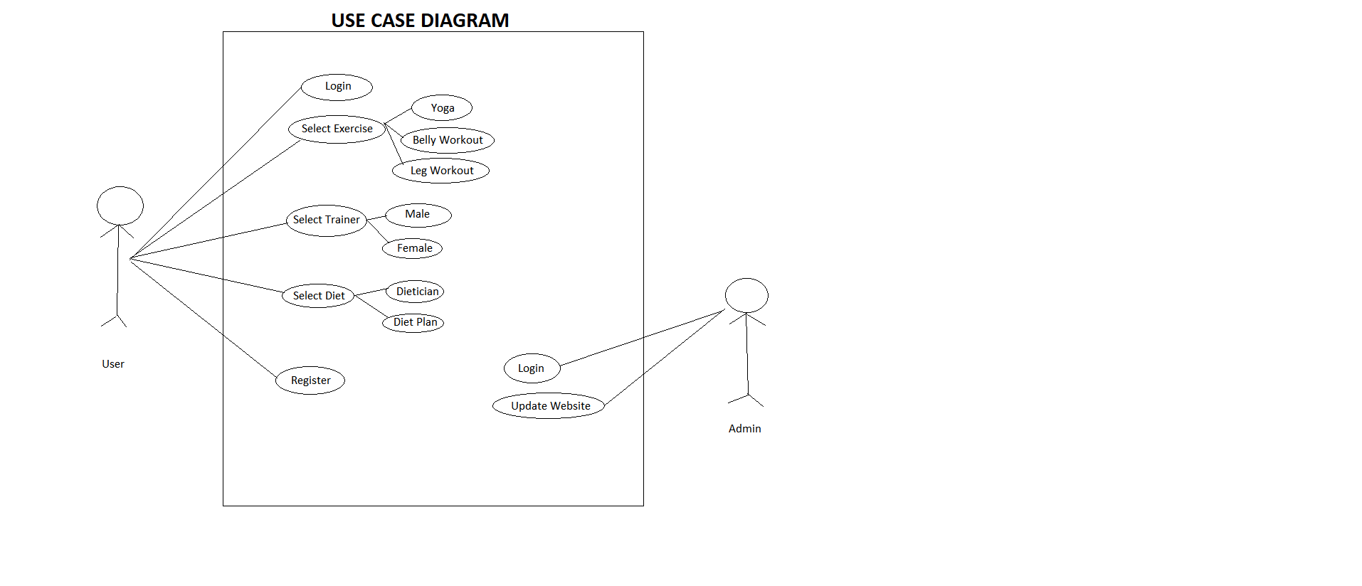

* + 1. **Sequence Diagram**

Sequence diagrams establish the roles of objects and help provide essential information to determine class responsibilities and interfaces. This type of diagram is best used during early analysis phases in design because they are simple and easy to comprehend. These are normally associated with use cases and are closely related to collaboration diagrams and both are alternate representations of an interaction.

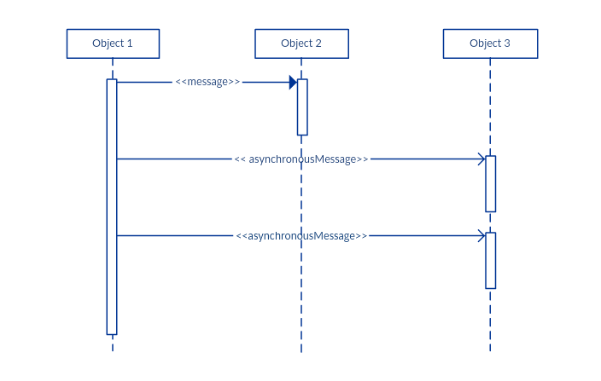

**CHAPTER 5**

**IMPLEMENTATION**

* 1. **System Architecture (Design)**

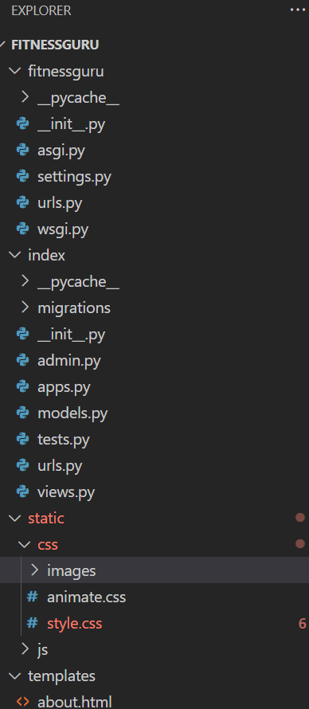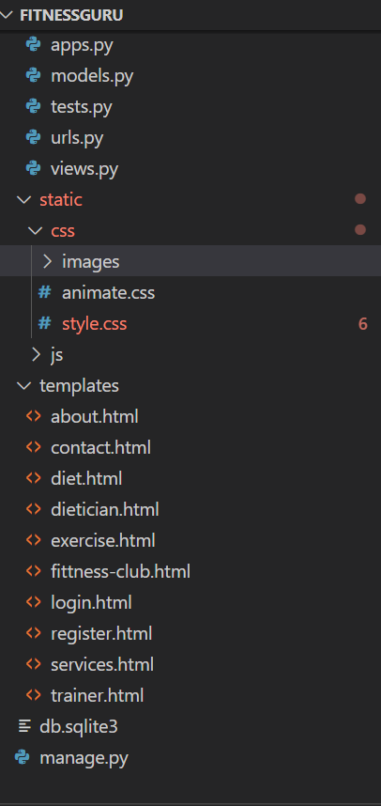

**CHAPTER 6**

**RESULTS**

**Home Page:**

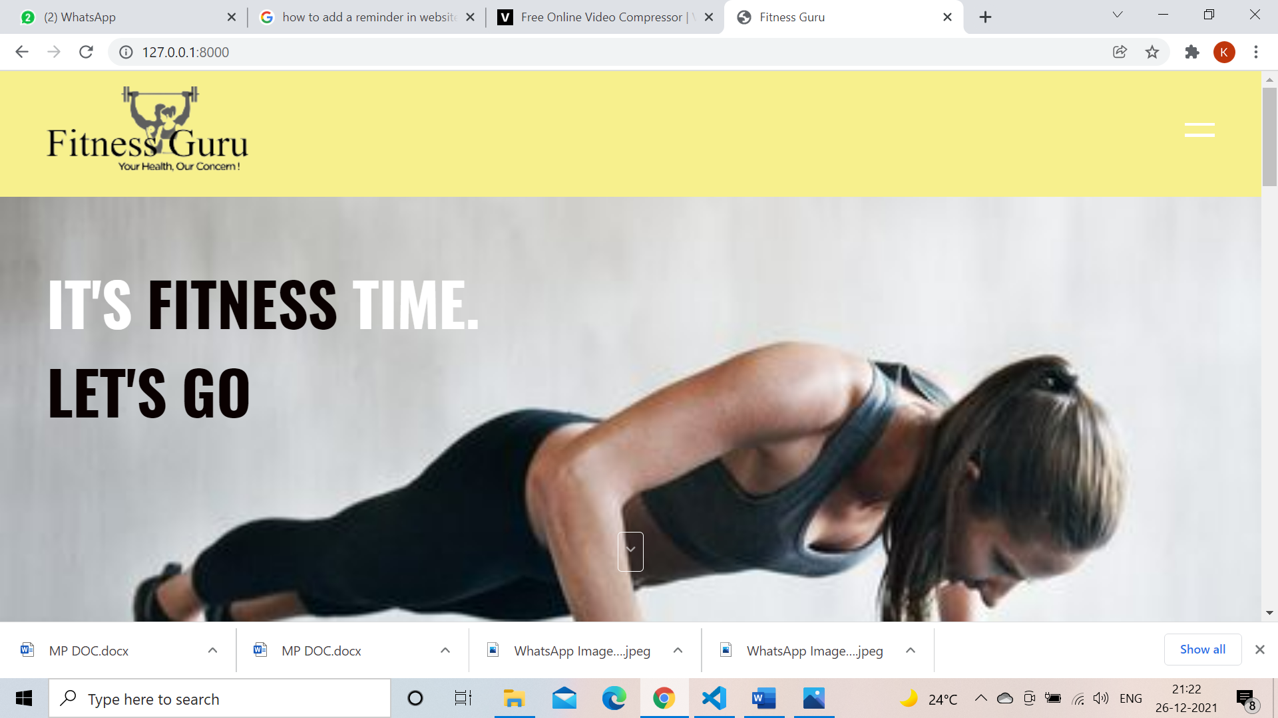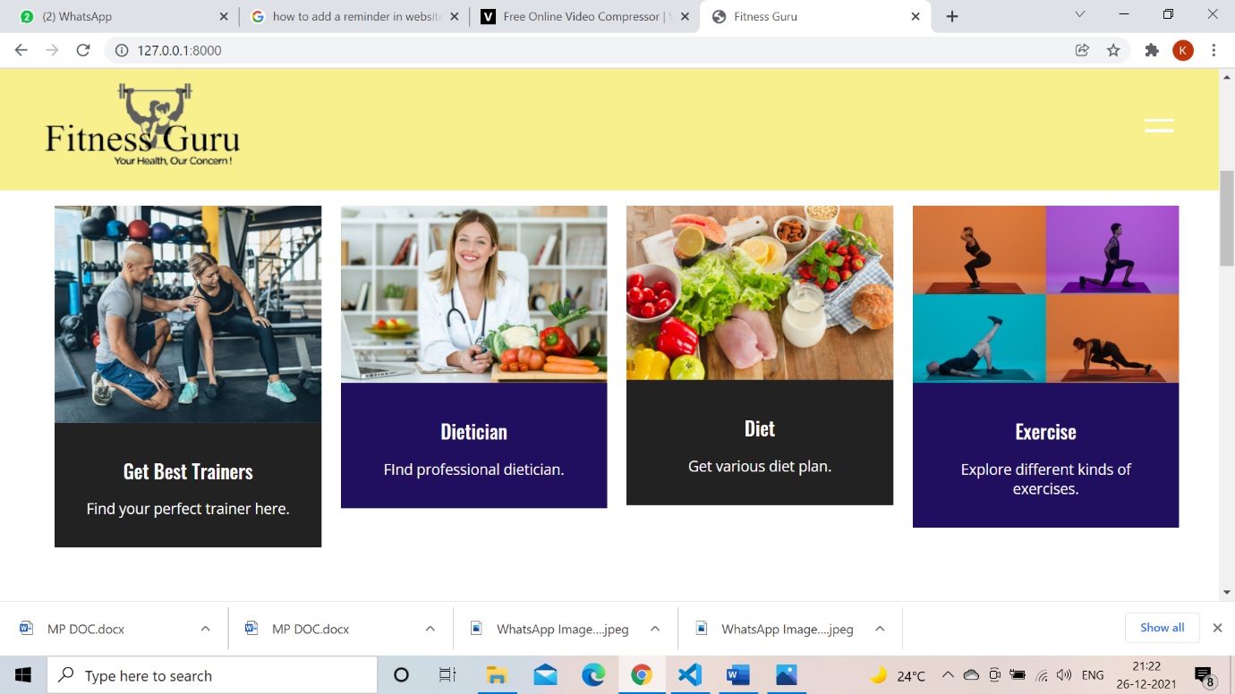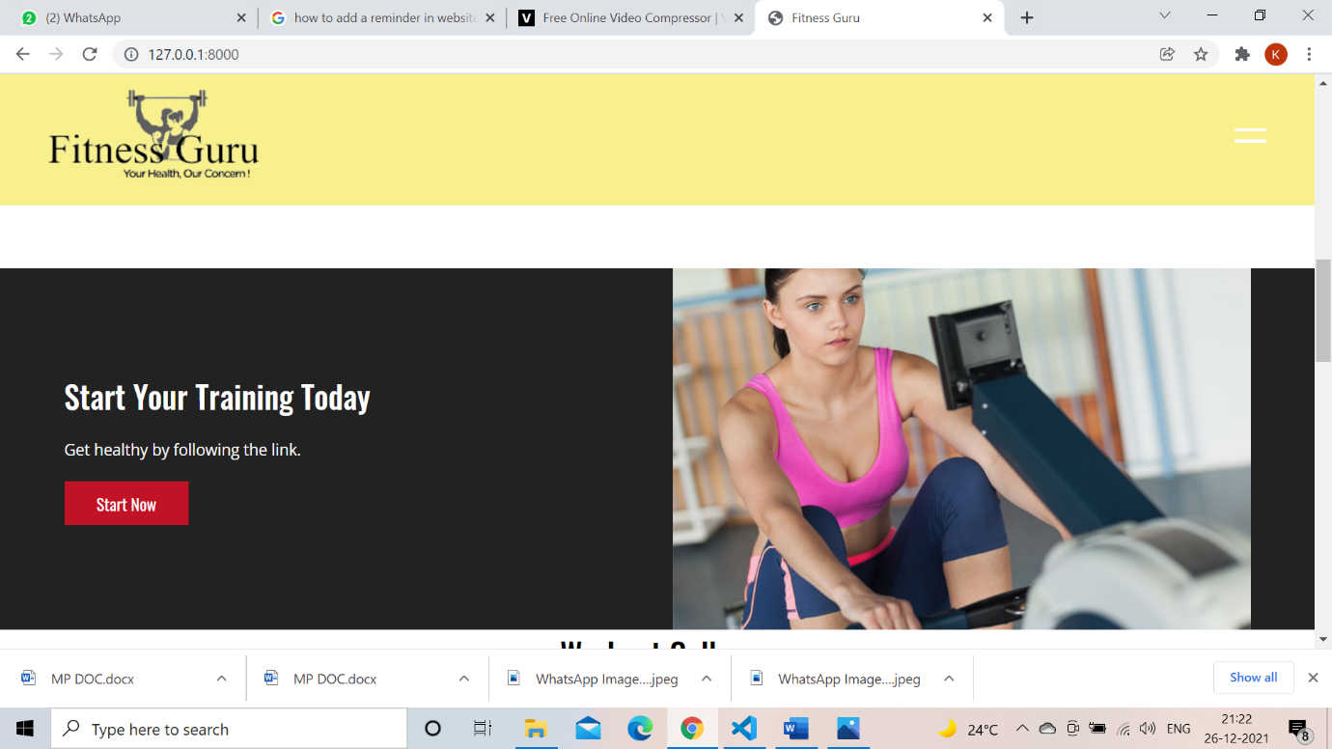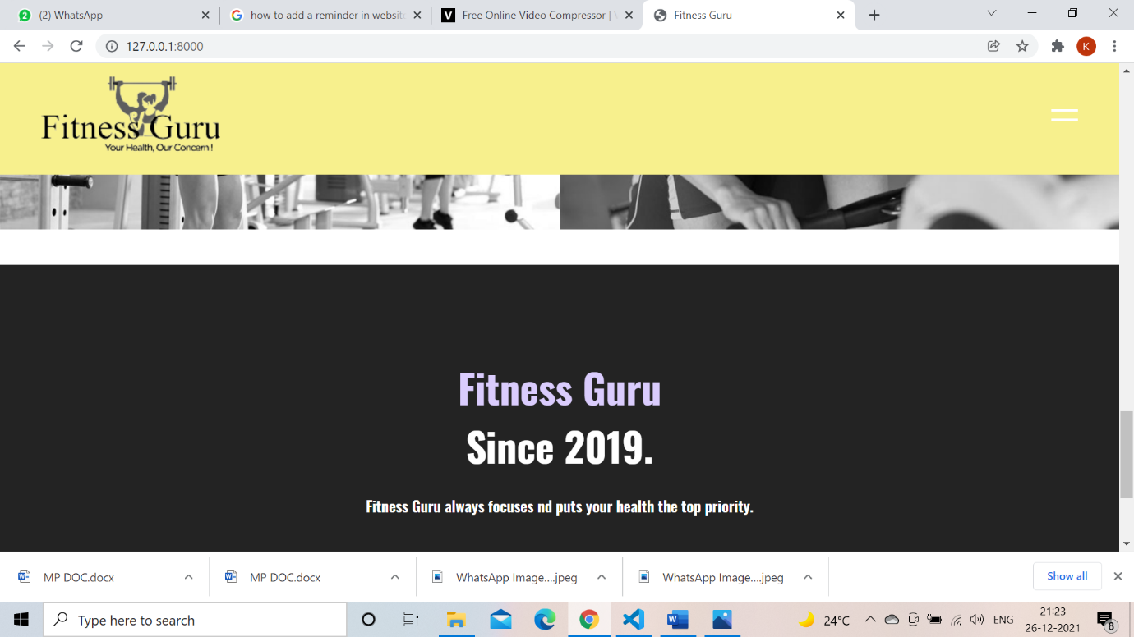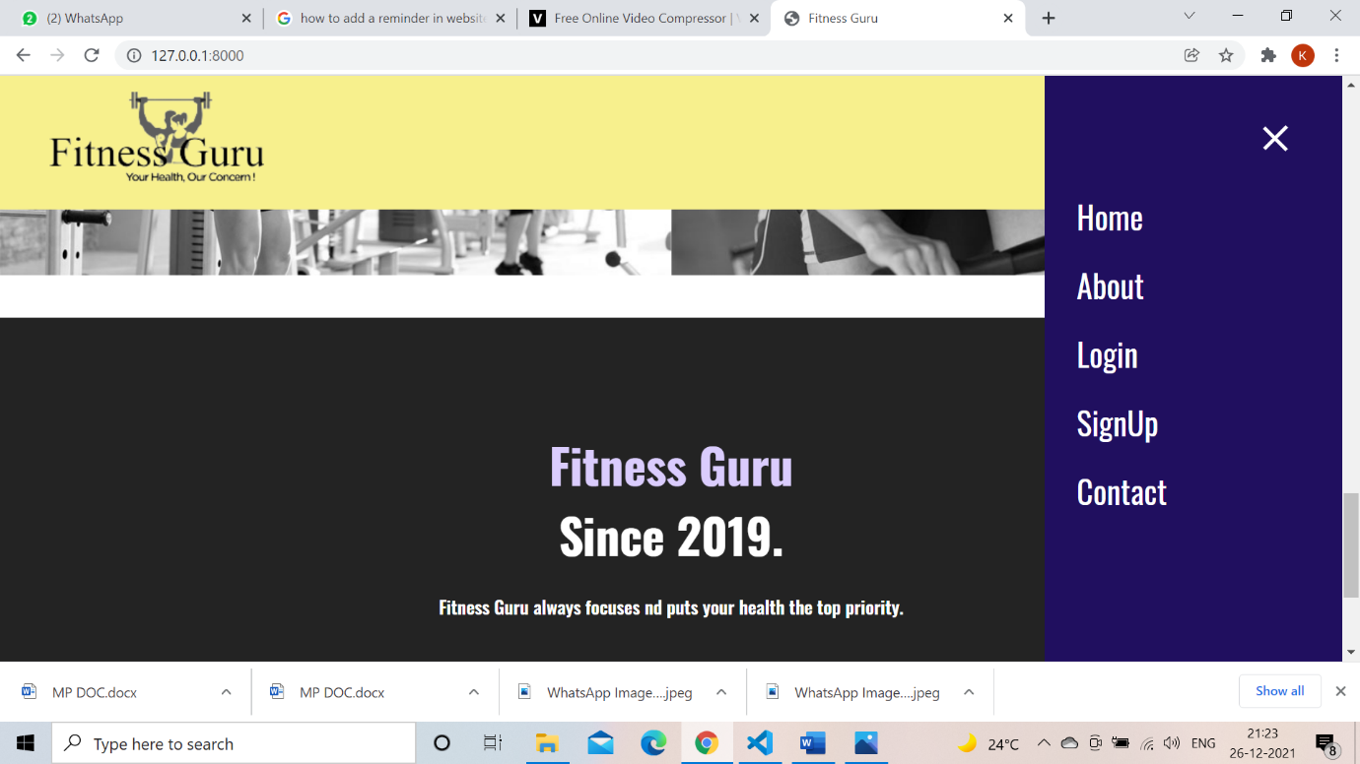

**Login Page**

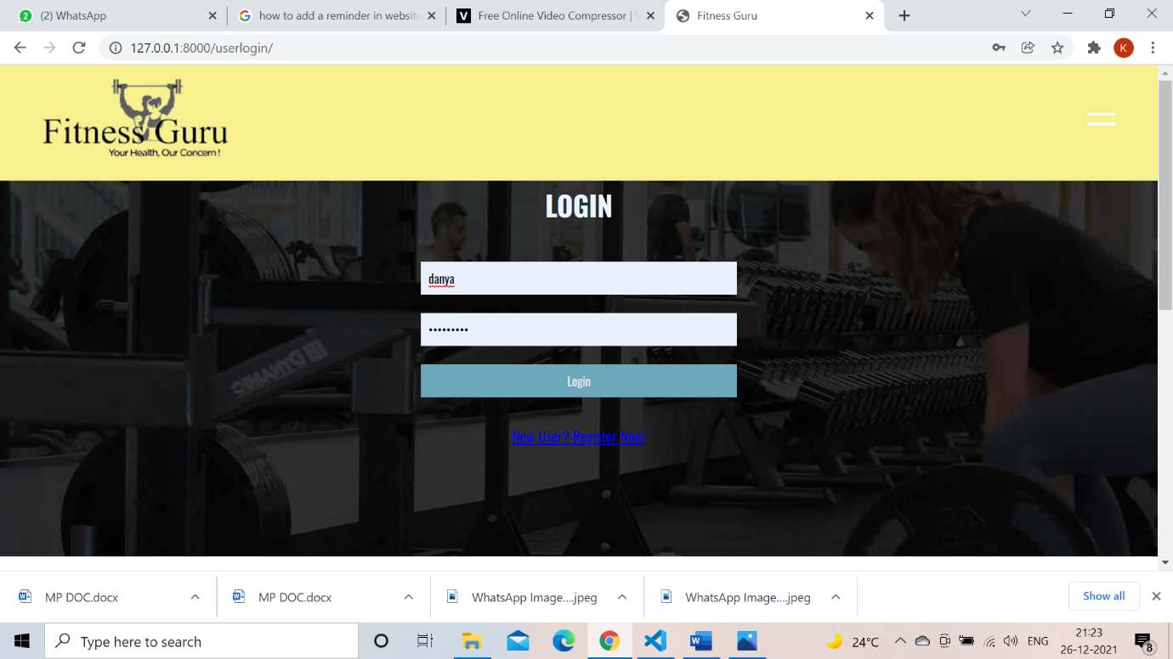

**Sign Up Page:**

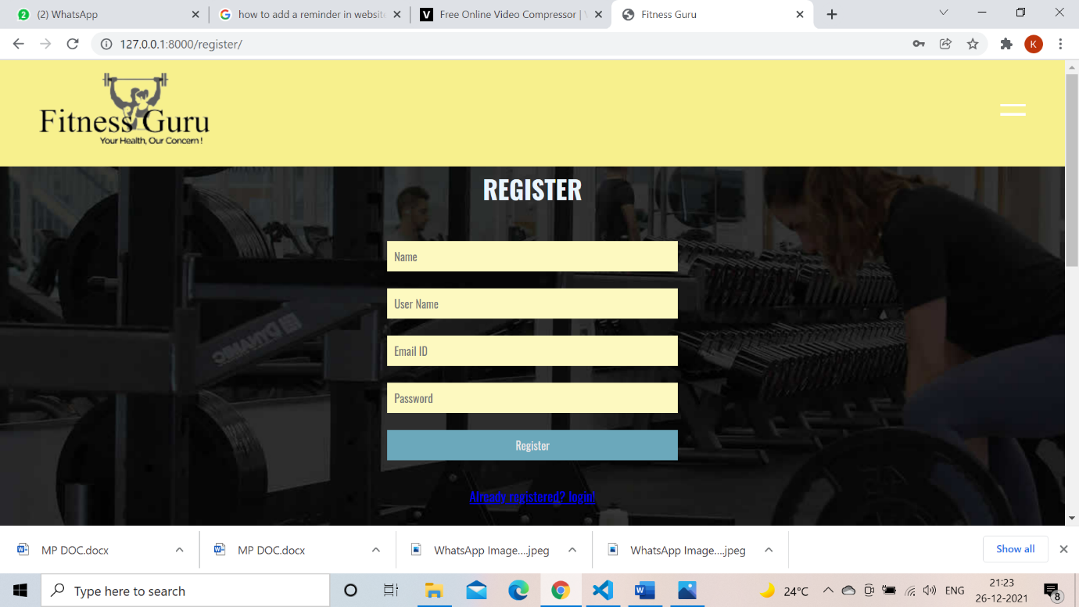

**Services page:**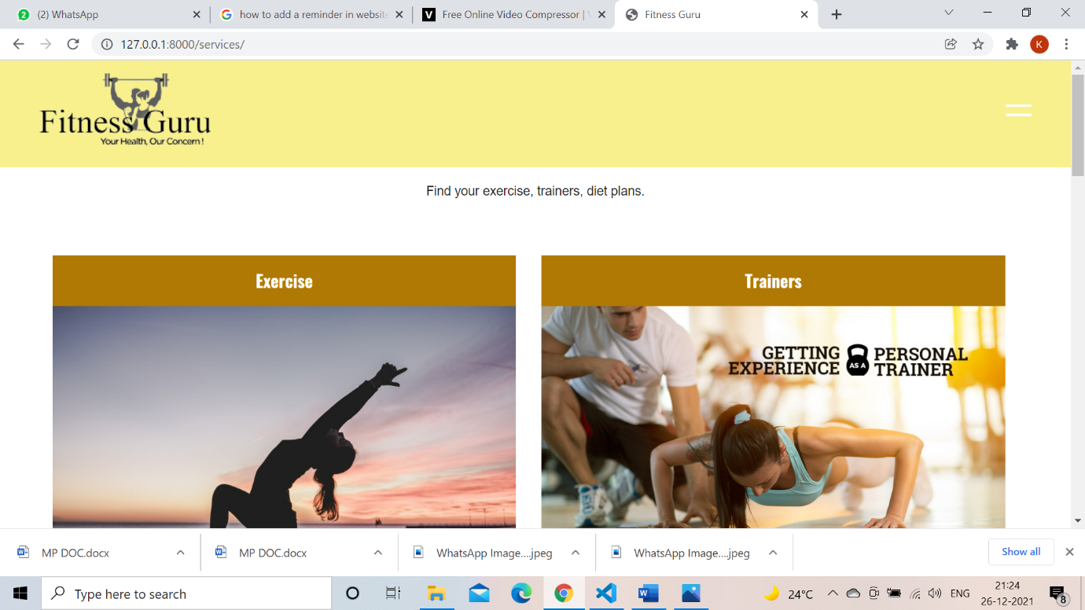

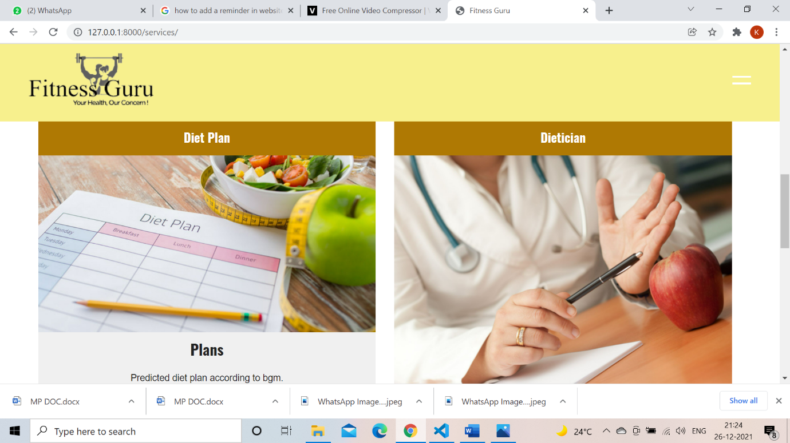

**Exercise:**

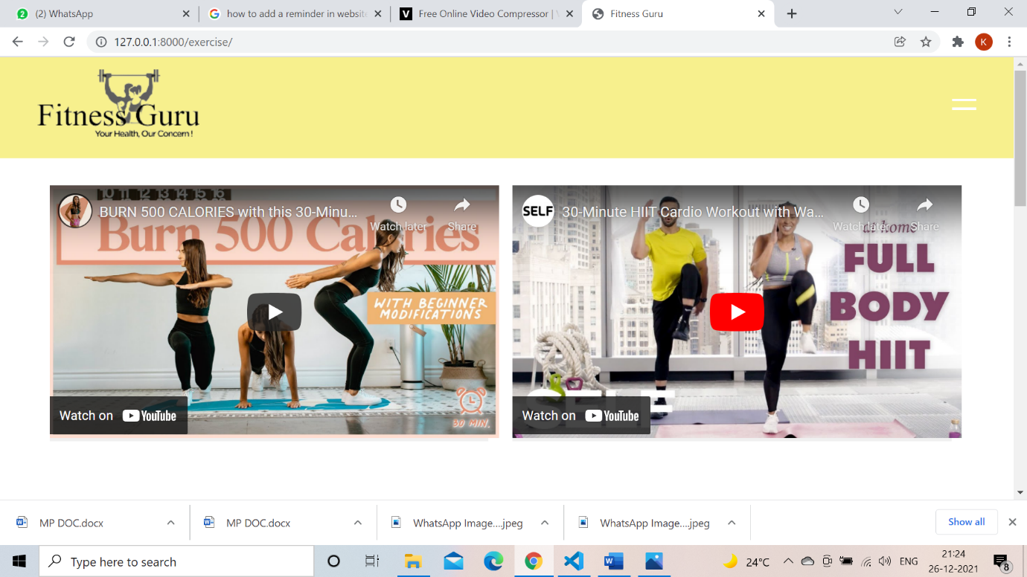

**Diet:**

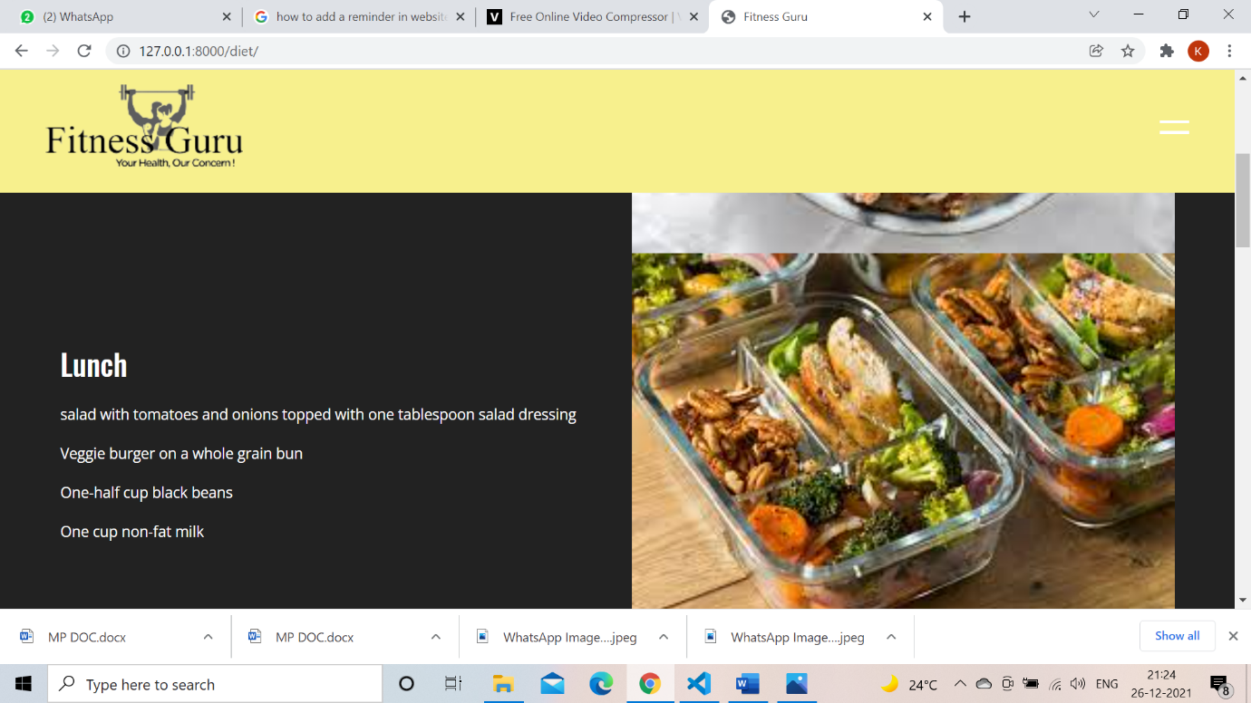

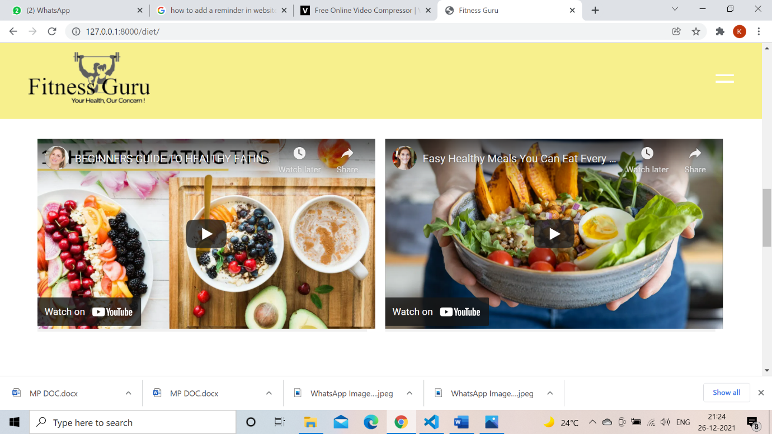

**Trainers:**

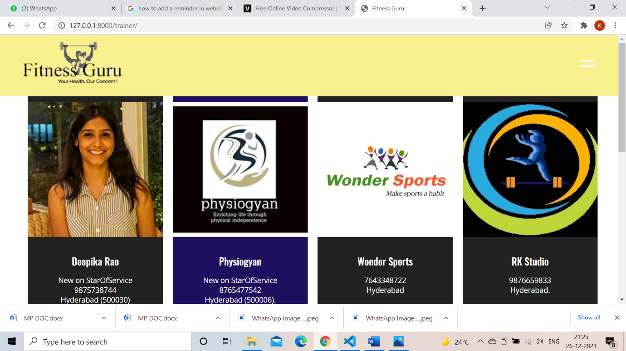

**Dietician:**

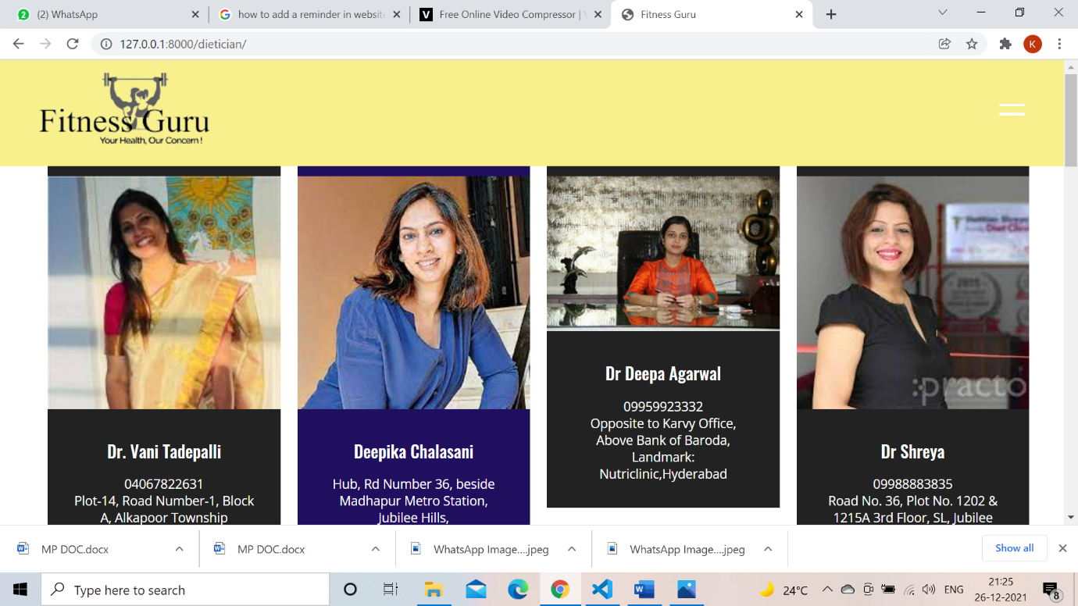

**Database:**

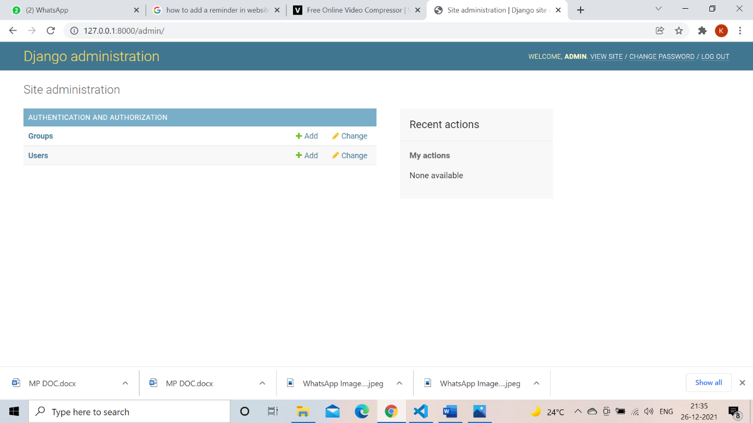

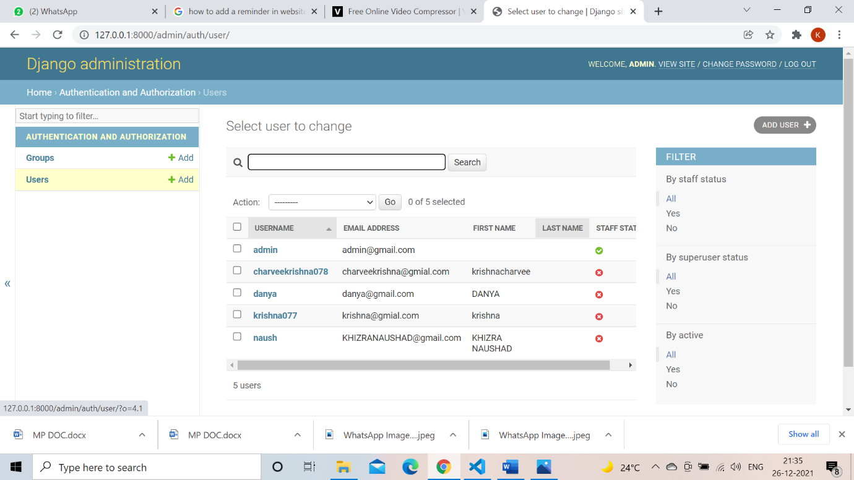

**CHAPTER 8**

**CONCLUSION AND FUTURE SCOPE**

**Conclusion:**

We believe that our website will be helpful for people who are aiming to lose/gain weight or adapt a healthy lifestyle. Our website will be the best place to follow and achieve fitness goals and lead a healthy lifestyle. It will definitely help people in leading a life happiness by achieving their fitness goals.

**Future scope:**

* An efficient chat system can be introduced between client and the application which will help clients to clear their simple questions or know more about the application.
* As it will provide the user with instructions and examples of one or more types of exercise, physical activity, nutritional programs, or some other fitness topic. Apart from this, including the medical health reports of the clients/users who have history of any kind of medication/diagnosis.

**Github links:**

https://github.com/khizranaushad/WEBDEV-PROJECT.git

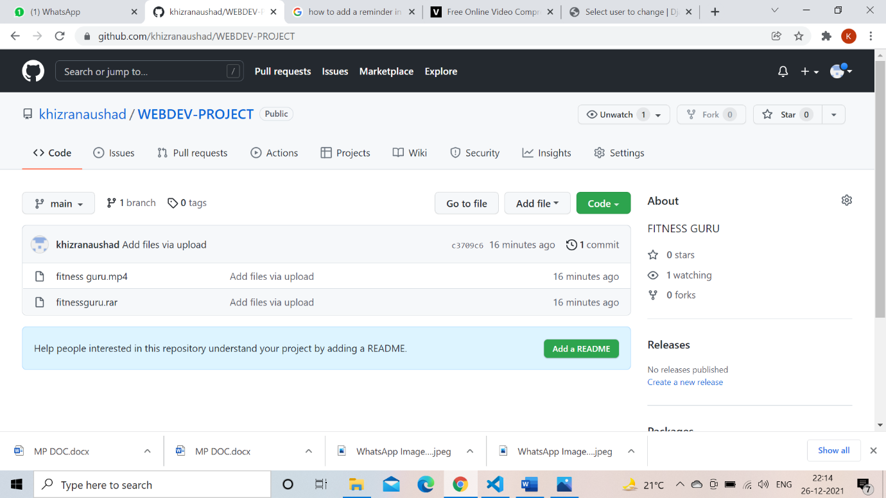

**CHAPTER 9**

**REFERENCES**

[**https://tympanus.net/codrops/css_reference/**](https://tympanus.net/codrops/css_reference/)

[**https://www.healthline.com/health/fitness-exercise/10-best-exercises-everyday#Stick-to-the-basics**](https://www.healthline.com/health/fitness-exercise/10-best-exercises-everyday#Stick-to-the-basics)

**https://www.vaultproject.io/docs/configuration/storage/mysql**